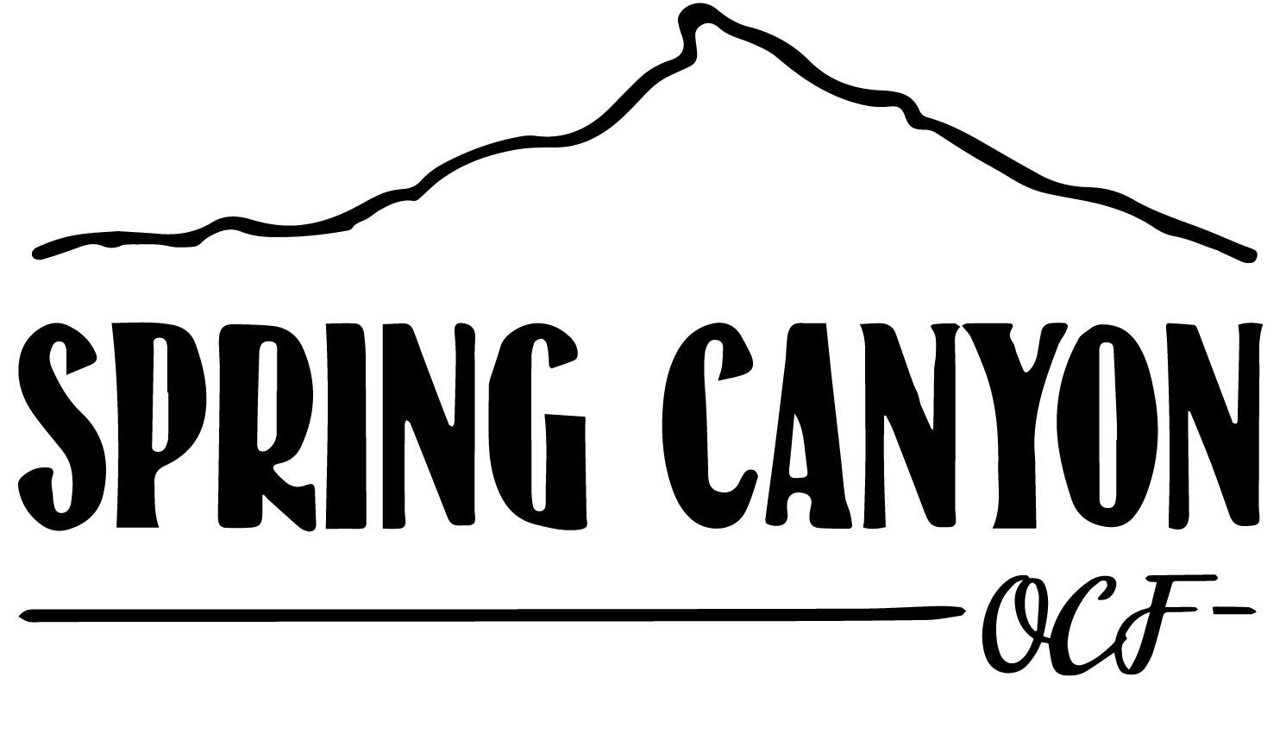

SUMMER CELEBRATION
SUGGESTED PACKING LIST
This list will help you pack for your Summer Celebration with Spring Canyon. Spring Canyon is located at over 9,000 feet in elevation and weather will vary during your stay. Daily temperatures can range from the mid 80s to the low 30s and rain is to be expected. We are located closer to the sun than you may generally be accustomed to; sunscreen and sunglasses are highly recommended. The following list contains suggested items in addition to your personal packing list to ensure you get the most out of your time in Colorado.

- Weekly toiletries (shampoo, conditioner, toothpaste, etc.)
- Prescription meds
- Baseball cap or visor
- Sunscreen, lip balm, insect repellant
- Sunglasses
- Flashlight or headlamp
- Hiking boots or athletic shoes
- Clothing layers (fleece or sweatshirt midlayer; puffy or external jacket; waterproof outer layer)
- Water bottle
- Swimsuit (if planning on going to the Hot Springs or Whitewater Rafting)
- Backpack or daypack
- Bible, pen, and paper
- Sandals with backstrap (and closed toes, no Crocs!)*
- Long Pants (Jeans, Carhartts, etc.)^"

If you have any questions about the above suggested items, please contact Spring Canyon.
We look forward to seeing you during your stay.
*Rafting Specific
^ATV Specific
"Horseback Riding Specific

